Public Transport Accessibility Group (PTAG and CPAG ) DRAFT Terms of Reference – Update 28 February 2023

Purpose Statement
Considering the intent of the New Zealand Disability Strategy , the New Zealand Transport-Evidence-Based-Strategy, the United Nations Convention on the Rights of Persons with Disabilities, and the new Whaikaha - Ministry of Disabled People, the PTAG advisory group will work with AT staff and key stakeholders -

To achieve an accessible transport environment in Auckland where people of all ages and abilities can access transport choices suitable to their needs; to go about their daily life easily, affordably, safely, and as independently as possible.

PTAG will be guided by AT’s Vision, Values and Objectives

- Auahatanga Better, bolder, together
- Whanaungatanga, We connect
- Tiakitanga, Safe with us
- Manaakitanga We care, Full stop

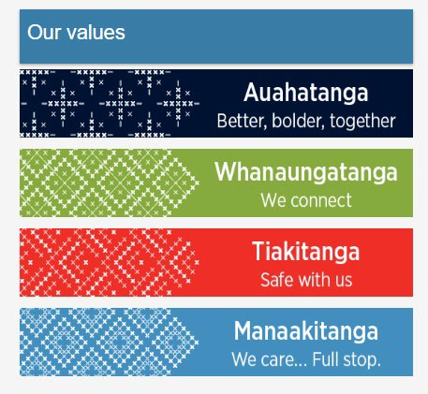

The Transport (AT) Values shape how AT delivers easy journeys and connects people and communities.

AT’s key objectives are to:
- Make Tāmaki Makaurau’s transport system safe
- Provide excellent customer experiences
- Tackle climate change and look after our resources
- Support Māori wellbeing, outcomes and expectations
- Build effective relationships with our communities, partners and stakeholders
- Deliver great value for money
- Make AT a great place to work

Auckland Council’s Auckland Plan 2050, as show in the diagram below, has a number of strategic outcomes. Core to PTAG is supporting the ‘Belonging and participation’ and ‘Transport and access’ outcomes. These are delivered through Auckland Transport’s objectives.
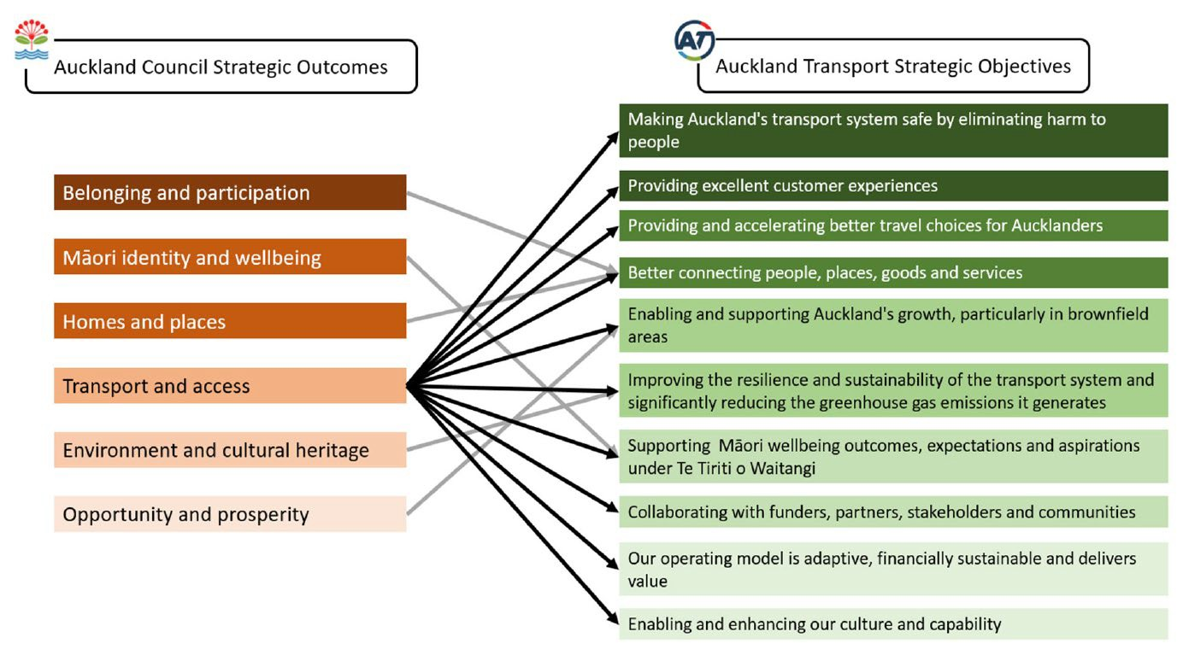

This includes the whole travel experience from when Aucklanders plan their journeys until they arrive at their destinations and comprises the full transport network that AT is responsible for. PTAG is focused on the public transport system, particularly operational matters, and can include related Accessibility issues affecting good public transport outcomes.

PTAG is a working group of Subject Matter Experts in Accessibility that provide guidance and clear direction to Auckland Transport management and key stakeholders relating to key strategic documents and related project delivery including:
- Implementation of the Auckland Transport Disability Policy 2013 and the Accessibility Action Plan 2022-24. Support the work related to the Regional Public Transport Plan (RPTP) 2018-2028 in areas focused on Accessibility objectives and outcomes.
- Support of the work of the AT Statement of Intent (2022-25) in areas focused on Accessibility objectives and outcomes.
Other strategic plans connected to and supporting Accessibility that PTAG may assist with are listed in Appendix B.

In meetings members are expected to be active participants, by providing comment, questions, suggestions, advice and their subject matter expertise on the transportation areas of:
Availability, affordability, accessibility and acceptability of conveyances, safety, service information, operations of public transport vehicles (including taxis operating Total Mobility services, and other related subsidised public transport services), policy and strategy, to all people with impairments and access needs.

PTAG generally excludes design and build infrastructure matters. These are dealt with via the Capital Project Accessibility Group (CPAG). There may be occasions where PTAG might need to review operational plans that relate to live network matters.

PTAG Group Specific Objectives

The aims of the Group to meet its purpose are to provide both proactive and reactive insights and advice to enable Auckland Transport to make informed decisions by:

- Providing a forum for two-way sharing of information to facilitate better understanding of access needs for Auckland Transport to consider as part of its operation and for interest groups to, in turn, better understand the transport entity and its considerations in endeavoring to meet the various groups’ needs.
- Provide an opportunity for all to provide input into a variety of public transport operational projects within Auckland Transport and to other external agencies as well when necessary.
- Acting as a conduit for sharing information through their representative group to their wider membership, regarding a variety of transport related matters and sector specific initiatives.
- Identifying any barriers to current transport access either for consideration by Auckland Transport in its planning or for immediate redress where appropriate.
- Providing a mechanism by which Auckland Transport’s project managers, consultants, contractors and designers can gain insight into how they can better provide for the access needs of people facing accessibility challenges.

Structure

Internal representatives
  - AT Accessibility Lead (Meeting Chair)
  - AT Co-ordinator (Minute-taker and PTAG Business Support).

In attendance each month:
  - Manager, Metro Services Operations or designated team member,
  - Manager, Metro Rail Franchise or designated team member,
  - Manager, Metro Specifications (Fleet & Infrastructure) or designated team member,
  - Manager, Metro Real Time and Response or designated team member,
  - An Auckland Council representative on Universal Design or designated team member.

As required each month:
Other AT staff and Auckland Council teams may be in attendance to support PTAG meetings.

Preferred Interest Group Representatives:
  - General or physical impairment
  - Vision impairment
  - Hearing impairment
  - Cognitive impairment
  - Neuro diversity
  - Senior Citizens
  - A Representative for Youth with disability (ideally aged 18-25 years)

Selection of Interest Group Members

The selection process of Interest Group Representatives for PTAG is open for applications every three years. PTAG will have between five and ten Interest Group representatives to ensure balanced representation across disability and accessibility sector interests.
Interest Groups are selected on their ability to represent the views of their stakeholder community across the Auckland region.

Interest Groups will be asked to nominate a representative to serve on PTAG and an alternate to cover occasional absence.
Representatives and alternates are selected on the basis of:
  - Current level of representation on PTAG for that interest group
  - Individual competencies and use of public transport
  - Lived experience with relevant diverse communities
  - Ability to offer policy and strategic advice
  - Ability to gather feedback from, and share information with, members of the community
  - Understanding and representative of the diverse communities of Auckland supporting inclusivity and equity
  - Some ability to understand maps, plans and technical drawings and concepts (support can be provided to assist representatives to gain the necessary level of skill for this attribute)
In order for Auckland Transport to meet its obligations under its Māori Responsiveness Plan, PTAG group members will be provided with the appropriate support and training to understand Auckland Transport’s obligations to Māori and Te Tiriti O Waitangi. PTAG supports te ao Māori (the Māori world) of Te Aratohu - Māori culture, while reinforcing Accessibility in Public Transport.
When suggesting a representative and alternate the interest group will be asked to provide information as to the candidate’s understanding and experience of Auckland’s diverse community. Lived experience in Te Ao Māori or knowledge of the contemporary issues facing Māori communities is also desirable.
The PTAG Chair appoints Interest Group Representatives. PTAG and CPAG groups may have different member group representatives. Some agencies might have a selected member who will attend both meetings. While other member groups may only attend either PTAG or CPAG or have a different representative for each group. For this reason, the two meetings will be scheduled at different times.

Voices of Mokopuna - Mai World
PTAG supports the guidelines of the framework developed by the Office of the Children’s Commission. Mai World | Office of the Children’s Commissioner (occ.org.nz)
The name Mai World emphasizes the importance of young people’s voices. It encapsulates what it means to be child centred by focusing on children and young people within their whānau, community, society, within their world.
The word ‘my’ in English identifies the subject in relation to what sits around it. The kupu (word) ‘mai’ in Māori and in the Pacific world transcends language and is also coloured by what sits around it - aroha mai (love towards me), whakarongo mai (listen to me), titiro mai (look at me), kōrero mai (speak to me). For mokopuna the context they sit in shapes them, as well. The use of the word ‘mai’ makes a statement directional. This is true in the case of Mai World where the flow of knowledge is from the speaker to the listener, from the mokopuna who are speaking, to the adults around them.
PTAG aims to support the youth of Tamaki Makaurau- to listen and embrace their world when they tell us about it.
Membership Terms

All appointments of Interest Group Representatives for PTAG are subject to a three-year term date from the date of the first meeting attended. Renewal and reappointment of Interest Group Representatives is subject to the standard application process.

Member responsibilities and support
Members commit to attend PTAG, and to personally attend not less than eight out of ten of the annual meetings.
If a member cannot attend PTAG, the Interest Group is expected to provide an alternative representative from the same Interest Group who also needs to be nominated and approved with the same skill requirements. If AT feel that we are not getting the required representation, then we may ask the member and Interest Group to step down from PTAG.
Where a member is absent, without leave of absence, from four consecutive meetings of PTAG then the interest group will be advised of the non-attendance. Auckland Transport reserves the right to declare an interest group representative’s position vacant after discussion with the interest group.
Members are expected to comply with the Code of Conduct set out in Appendix A.
Members are expected to keep confidential any information that is shared in PTAG unless Auckland Transport confirm that it can be made public.
Auckland Transport will at meetings to ensure that a member’s disability
does not reduce their ability to contribute to the issues being discussed.

Fees
The Interest Group will be paid a meeting fee of $100 per hour for attending formal PTAG meetings. The fees applies to the PTAG meeting only, not to any work performed outside of meetings (e.g., preparation, representing PTAG at other forums, or administrative work). The expectation is that this is work that would be undertaken by the Interest Group as part of their normal operations (e.g., preparing topics to raise with Auckland Transport, communicating to their members, administrative work). The time spent travelling to and from meetings is not paid for.
Payment for meeting attendance does not cover involvement in other projects. Formal advice provided by Interest Groups to AT outside of PTAG will be agreed separately with project owners. This can include the terms of engagement and remuneration.

Meeting details
PTAG is not a decision-making body, it is an advisory body as such it is not expected that many formal resolutions will be passed. PTAG can, however, request the Chair to escalate their concerns to the Group Manager Metro Services. PTAG members may if invited to do so, email group emails or project teams and members, directly, to help expedite matters and copy the PTAG chair.
PTAG can determine its own meeting procedures, however, these will be based on NZ Model Standing Orders for Meetings NZS 9202:2003.
PTAG will have ten formal meetings per year, excluding January and December. These meetings will take place once a month on the 3rd Wednesday of each month at a location that is central to the region and within a building that is fully accessible to all prospective attendees. Meetings are usually in person, but may also be online. PTAG may be scheduled on the same day as CPAG or other meetings.
Members will maintain the confidentiality status of documents marked as such and other meeting materials shared in confidence with members by programme leads.
Draft minutes will be distributed to all members within ten working days after the meeting. PTAG meetings are not public meetings, therefore minutes are not published on the AT website.
Minutes will be formally reviewed at the next subsequent PTAG meeting.
The next meeting agenda and any papers will be distributed to all members at least seven working days before the meeting.

Appendix A: The AT code of conduct for advisory groups
It is expected that PTAG members will adhere to the AT code of conduct for advisory groups. The code of conduct may be updated periodically and can be supplied upon request.

Appendix B: Accessibility and AT Strategic Documents

PTAG is a working group of Subject Matter Experts in Accessibility that provide guidance and clear direction to Auckland Transport management, staff and key stakeholders relating to public transport in Auckland, and may refer to the following strategic documents:

- Support of the Vision Zero for Tāmaki Makaurau A Transport Safety Strategy and Action Plan to 2030. Safety can help reach other transport goals such as efficient use of space, health, accessibility, and sustainability.
- Support the work of Auckland Transport and Auckland Council’s Transport Emissions Reduction Pathway (TERP) with the objective focused on the reduction of transport emissions in line with Te Tāruke-ā- Tāwhiri: Auckland’s Climate Plan..
- Support AT alignment with Auckland Council’s draft Ngā Hapori
Momoho: Thriving Communities Strategy 2022 – 2032.
- Support of AT’s Māori Responsiveness Plan, and the Te Aranga Māori
Design Principles.
- Support work on the Auckland Transport Alignment Project | Ministry of Transport (2021-2031)
- Support work on the Future Connect - Auckland Transport's Network Plan (at.govt.nz)
- Support work on the Auckland's draft Parking Strategy
- Support work on the Roads and Streets Framework (2020)
- Support work on the City Centre Bus Plan (2021)
- Support work on the Hīkina te Wero Environment Action Plan 2020- 2030
- Support the work on the AT Diversity-and-Inclusion Strategy 2019-2022
- Support the work on the AT Pasifika-Network-Strategy (to 2023)
- PTAG will support and make connections where possible with other Auckland Council Plans and Strategies and projects that support Accessibility. Particularly the Advisory panels (such as Disability and Seniors) and the Disability Operational Action Plan (2015). Also; the Universal Design Forum (particularly the work with the Auckland Design Manual and Universal Design principles Universal Design - Auckland

Design Manual). Other examples include the Tāmaki Makaurau tauawhi kaumatua- Age-friendly Auckland Action Plan Age-friendly Auckland Action Plan (aucklandcouncil.govt.nz).

