Deafblind Association of New Zealand Charitable Trust

Report to Board on Seminar 2023
cc: Ruth Dyson CQSM, Patron of Deafblind Association New Zealand; Hon. Poto Williams/Hon Priyanca Radhakrishnan, former and current Ministers for Disability Issues; Paula Tesoriero, Chief Executive Whaikaha - Ministry of Disabled People; John Mulka, CEO Blind Low Vision New Zealand; Dr Sanja Tarczay, President World Federation Deafblind; Chris Woodfill, Associate Executive Director, Helen Keller National Centre, USA and Board Member of World Federation Deafblind; Frank Kat, President of Deafblind International (DbI); Latoa Halatau MNZM, Co-Chairperson of Pacific Disability Forum and Director Vision Pacific; Charlotte Gordan, Phonak New Zealand; Dr Chandra Harrison, Director, Accessibility Advisors.
Date: 17 April 2023
Subject: Be Seen Be Heard Be Connected - Deafblind Association of New Zealand Charitable Trust Seminar–Reconnecting,
22-25 January 2023.
From: Amanda Stevens, Executive Officer
This report outlines the Aotearoa New Zealand context for planning a seminar for deafblind while still in a “Covid live” environment, logistical challenges, and the successes and outcomes that have inspired plans for another seminar in 2025. We also note the learnings that offer us scope for improvement going forwards.

Thank you to our Sponsors
It takes vision, energy, and commitment ++ to put a seminar together for people who are marginalised in so many ways and to keep deafblind at the centre of it all. We are pleased to thank everyone we approached for support because everyone, without fail, believed in us and said yes ++, including support of our physical, emotional, and mental wellbeing!
- Blind Low Vision New Zealand
- Access Advisors
- Phonak New Zealand
- Deaf Aotearoa iSign
- Community Operations, Lottery National Community.
- Vision Pacific Charitable Trust
- Fulton Hogan
- Aotearoa Adaptive Archery
- Touch Compass
- Audio Described Aotearoa
- Warren & Mahoney Architects
- Kevin Prince
- Sarah Walters
- Liberty Market

Contents
Thank you to our Sponsors 2
Background 4
The Venue 4
Purpose 5
Voices in the Room 5
Cultural Engagement 6
Volunteers 6
Communications 6
Outcomes 7
What we did well: 8
What we can improve: 9
Next Steps 9
Photographs 10
Strategies that underpin our work 13

Background
hBefore the 2021 seminar was over delegates were asking when the next one would be. Blind Low Vision NZ received the report from that seminar and were subsequently happy to support with funding for 2023, including the deposit required by the venue in the 2021/22 Financial Year. In the latter months of 2022, the Executive Officer became unwell and was able only to offer minimal input into planning. At this stage the board, under the direction of the President, Vaughan Dodd, supported in a myriad of ways, underpinned by the expertise and warmth of the Board Secretary, Sarah Walters. Further, the End of Year break added extra pressure in the reduced ability to contact people. Given that the Board are unremunerated, and that the Executive Officer and Board Secretary contracts total less than one full time equivalent, this was a supreme effort by all involved. It is noteworthy that two of the current Board Members came to their positions as a result of attendance at the 2021 Seminar. In addition four very special women stepped forward during the planning of this seminar and offered me their knowledge, skills, wisdom, in some cases their families, and especially their individual passion which drives their work and they asked me to use it wisely. Sarah Walters, Dr Chandra Harrison, Director Accessibility Advisors, CharlotteGordon, Phonak, and Sali Mann, lead volunteer, enriched this seminar with logistics, photography and social media skills delivered with such verve, support in everything sound including equipment, knowledge, connecting every individual in, and music, and arts and craft that made this event one of Best Practice Wellbeing for Deafblind. The fellowship around the craft and music and kōrero this generated was much in evidence.

The Venue
Acknowledging deafblindness as a unique disability when meeting needs we were faced with finding a venue that was accessible, quiet enough, Guide Dog friendly and welcoming, sourcing superb sound quality equipment, coordinating complex travel requirements, ensuring provision of Tactile interpreters, volunteers, guidance for presenters on delivering to deafblind, and then connecting with our community in their preferred format to help mitigate any personal challenges in attending. We averaged around seven one-to-one communications for every delegate who attended as well as those who were unable to come at the last minute.
College House, University of Canterbury, Christchurch, were engaged as an optimal venue for us and offering availability late January in between semesters. The warmth, generosity, and engagement with our community’s needs Shirolee and Raylene showed from the first visit to the last hurrah was fabulous. They put tape across the sneeze guard at the food counter so we wouldn’t bump our heads, put braille on the food cabinets, made sure house keeping left everything exactly where they found it even when it appeared counter-intuitive to them, supplied a doggy-do bin, supported or needs around a few very heavy fire doors, and goodness knows what else we didn’t know about behind the scenes. All feedback received to “would you want us to use this venue again” was a unanimous yes. This is an exceptional outcome given the diverse needs of our community. In my utopia inclusion would start at College House and radiate right across the motu!

Purpose
Our tag line and theme are: Be seen, Be heard, Be connected – reconnecting. We promised a positive view of the world and the right of Deafblind people to be playing active and fulfilling lives doing whatever, and wherever we choose to do and to retain choice and control. The programme was exciting, Topics varied, and included technology, service delivery and advocacy. Guest presenters discussed research, developments in hearing aid technology, low vision services, digital technology, Cochlear Implant funding, education, health, Braille, and underscoring the avenues for our being seen, being heard, and being connected. Attention to Health & Safety we decreed paramount, especially in an environment still very much alive with Covid. We focused on developing a physically, emotionally, and culturally safe environment for all concerned as we know this is critical to encouraging full and frank engagement.

Voices in the Room
In Grade One Listed buildings and amongst the rose gardens and award-winning courtyard we counted fifty eight (58) voices from across Aotearoa New Zealand. Of these twenty-three (23) are deafblind. Our community were represented amongst delegates, presenters, including our Board, and Executive Officer. With authenticity it can be noted that deafblind lead from the front. Collaboration however is the key and richness was input so willingly by whānau (family), Tactile Communication interpreters, presenters including the CEO and staff of Blind Low Vision New Zealand, Caroline Selvaratnam, Audiologist/Adult Team Leader, The Hearing House and colleague Michelle Holland, Southern Cochlea Implant Programme, And, zooming in, international presenters including Ying-zi Xiong and Peggy Nelson, Center for Applied and Translational Sensory Science at the University of Minnesota, and Sanja Tarczay, President of the World Federation of the Deafblind. Presenters were inspiring and knowledgeable and feedback shows we learned so very much. Our delegates offered authentic and graceful thank-you speeches based in lived experience in response.
It was with shock and sadness that we learned from interpreters on the opening day of seminar that one of our community would not be attending because his primary care giver, and our contact, had died. No one else had known he was coming and he has no independent access to information. He has moved to residential accommodation and we are still looking for him. This highlights the extreme marginalisation of some of our community and the work involved to stay connected.
Deafblind Association NZ formed a holistic community over the four days and we were privileged to have our patron, Ruth Dyson, Companion of the Queen’s Service medal with us.

Cultural Engagement
While every effort was made to support cultural needs, the organisation recognises there is still a long way to journey towards understanding te ao Māori and inclusive engagement with Tikanga and diverse cultures in Aotearoa NZ. We acknowledge being freely, wisely, honourably, and lovingly gifted cultural understanding around Te Ao Māori connecting some to our Iwi delegates. One of the learnings however is that before the protocols come the people and it takes quite some time to build culturally appropriate relationships that are sustainable before an event. While all feedback indicated cultural needs were met, small indications at the time do not uphold this entirely and we look forward to furthering respectful engagement.

Volunteers
While we started six months in advance sourcing potential volunteers, with a lead volunteer committed, it was still difficult to get people to commit closer to the time. Six weeks out we could no longer complete Police Vetting and so became reliant on family and friends. Pre-seminar included a Zoom session two days out followed by a training session on site with orientation. It soon became apparent we were surrounded by volunteers who quickly became a team exuding warmth, practicality, enthusiasm, empathy, and an unquenchable desire to learn. Feedback showed we had offered extensive training both by Zoom in advance and in the induction for volunteers session held on site before delegates arrived. Every volunteer said they had learned something that enriched them.

Communications
- Charlotte Gordon, Senior Audiologist, Phonak NZ gave full meaning to the phrase “Best Practice” with support for all of our hearing needs. She supplied all of the sound equipment, especially linking into Roger Pens and then worked tirelessly with individuals to offer the best quality for access to information.
- Critical to understanding the nature and complexity of deafblindness is the impact it has and we started there with a presentation by Kevin Prince on Captions, Lip Reading, and Hearing. The link here is quoted as being a work in progress and we highlighted it to audiologists present. The link is available on our website:
https://www.w3.org/TR/saur/
- Living with braille in action – gift tags, programmes, thank-you cards, and food cabinet.
- There were some challenges to sourcing enough Tactile Communication interpreters, even starting five months out and this highlights the deficit of trained Communicators in Aotearoa for the critical access to information for deafblind through both Tactile Communication and Social Haptics. We simply never found enough interpreters to cover need although we worked tirelessly with all five interpreting agencies and Blind Low Vision NZ right up to the first day of seminar. We were pleased to have Paula Tesoriero, CE Whaikaha, acknowledging this work needs to be done also. Currently the only training on offer is ad hoc through skilled Deafblind Coordinators, Blind Low Vision NZ and there is no qualification attached to this work, making the skill difficult to measure and also difficult to source appropriate interpreters prior to an event. iSign provided three people however we needed more as all events were not able to be covered.

Outcomes
In listening to deafblind aspirations beyond the challenges, and professionals present, we have captured a few voices that give qualitative validity to the seminar. More importantly this drives demand for future seminars:
We started from here | We demonstrated progression here
Exploration of how to most effectively engage with deafblind community | Development of programme, challenges to attendance supported for confidence in attendance, registration supported for best accessibility
Deafblind seeking peer understanding and mitigation of isolation | Deafblind connected through face-to-face conversations in formal and informal settings.
Deafblind individuals looking for their next step | Deafblind delegates, presenters, Board, researcher, Executive, demonstrate possibilities.
Limited exploration of cultural perspectives for deafblind | Feedback gathered through initial engagement, seminar participation, and follow up feedback informs further engagement
Lack of surety around supports and services in pursuit of wellbeing, employment, training, accessibility | Service providers, access to programme information, and tactile communication interpreters show service in action with engagement demonstrated
Challenges to deafblind equity, engagement, and opportunities | High energy engagement by all as solutions to day-to-day barriers were supported by face-to-face opportunity in both formal and informal times.
Engagement with arts and culture, politics, employment support, and validity of individuals’ skills limited nationally | Opportunity provided for upskilling and learning connected across Aotearoa and global connections.
Service providers and agencies seek understanding of accessible and knowledge-based opportunities for engagement with deafblind | Strong and positive feedback from presenters including Blind Low Vision NZ, Southern Cochlear Implant Programme, Phonak, Pacific Vision and Accessibility Advisors requesting stronger engagement and offering further opportunities to connect.
Need for strengthening mana (status/validity/authority to lead) for organisation | Funder and delegate feedback very positive and requesting further seminars.  Professionals working in the deafblind field were asking to come as opportunity for professional development was recognised. This seems to be the only formal opportunity for cross service/agencies to work together with deafblind.
Solutions to technological barriers explored | Delegates swapped knowledge around their own devices (eg. iPhones) as well trying new devices provided by Blind Low Vision NZ, Pacific Vision and Phonak.

What we did well:
- The program was well put together, very informative, good choice of presenters. There were some recreational activities which were excellent;
- Registration was very straight forward: The information pack was very thorough and received in advance so as to be well prepared as possible for the event;
- Where presenters made information available in advance this was very helpful;
- I feel more informed from the seminar thank you. I discovered what I am entitled to when it comes to being provided with sign language interpretation for everyday life. I was also provided with a number of connections.
- One delegate said “Shared experiences, struggles, barriers and the spirit of overcoming that shone through spoke to me. We each have a story to tell whether individually or representing an organisation. It is in the sharing of one’s experiences, opening one’s spirit to learn from another’s journey that we grow stronger, realise we are not alone in our challenges and struggles and we can develop greater resilience to forge onwards and reach out a hand of embrace to those who need encouraging.”
- Some delegates indicated that the seminar supported their leadership development – networking helped with this.
- Connecting our delegates directly with the Minister for Disability Issues and Chief Executive of Whaikaha.
- Feedback forms were sent to all presenters with resounding requests about how to keep connected, both with Deafblind Association New Zealand and our community, as well as other presenters’ organisations to support collaboration. Here are a few of their comments we were most pleased to receive:
- Our primary funder, Blind Low Vision NZ, CE John Mulka – “By far one of the best events I have been to while in New Zealand.”
- Southern Cochlear Implant Programme, Michelle Holland – “I was also moved by the reflections from your gift-presenters to each guest speaker … the sharing of their personal stories built a sense of connection to the presentation. I am very aware that the whole event succeeded by establishing new connections, supported re-connecting within the group members and solidifying long-established relationships. I am honoured to have been part of this event.”
- Jessica Nelipovich, manager Guide Dog Services “I learned a lot about presenting to deafblind through tactile communicators. This was a first for me.”

What we can improve:
- Delegates wanted more cameos from each other.
- Some feedback indicated that we did not get the programme out in a timely manner.
- Board members mingled as much as possible to talk about our work. Two people from this seminar expressed interest in joining the Board at some point.

Next Steps
- Determine geographical location, secure fully accessible and appropriate venue, and develop culturally sustainable engagement for 2025 Seminar;
- Ensure interpreters are available for all seminar activities including recreation, mealtimes, casual conversations, and evenings;
- Communicate with future presenters that their impact is vastly improved when presentation material, including Power Point, is provided in advance;
- Develop conversations and relationships that acknowledge the need, and financial support, for Communicator guides, especially when our community travel;
- Continue to collaborate with Blind Low Vision NZ staff to develop a video of short cut signs which Tactile Communication interpreters can access prior to future events to help speed up and provide clear understandable communication;
- Continue to liaise with Service Providers to ensure appropriate and successful pathways for technology support;
- Continue to liaise with Whaikaha and the Office for Disability Issues regarding understanding and policy change to support deafblind needs.

Photographs
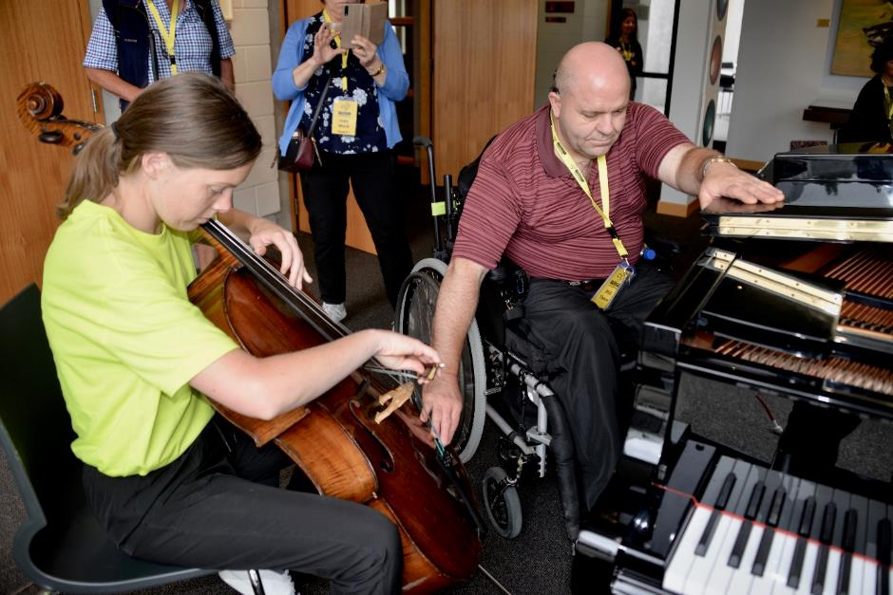
Deafblind attendee Phil feels the music being played on cello by volunteer Ellen (wearing one of the bright volunteer t-shirts) and on the piano by deafblind attendee Kathryn (not visible).
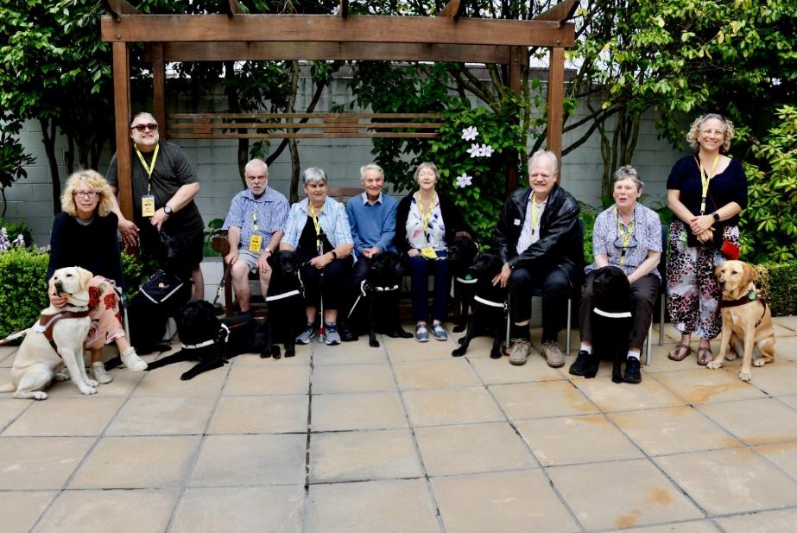
Guide dog handlers and their dogs – Sharon, John, Vaughan, Judy S, Don, Ann, Clive, Judy N and Sally.
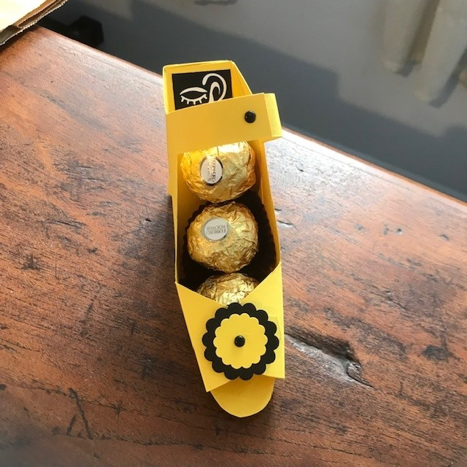
Part of the gift bag given to presenters, in Deafblind Association NZ colours.
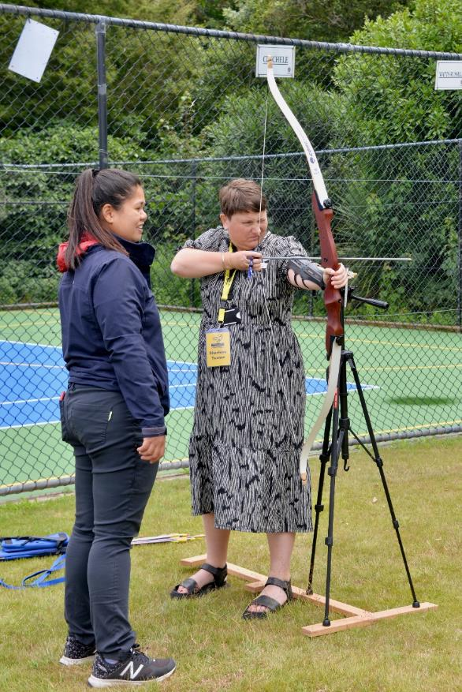
Attendee Sharlene lines up the target while a volunteer from Aotearoa Adaptive Archery looks on.
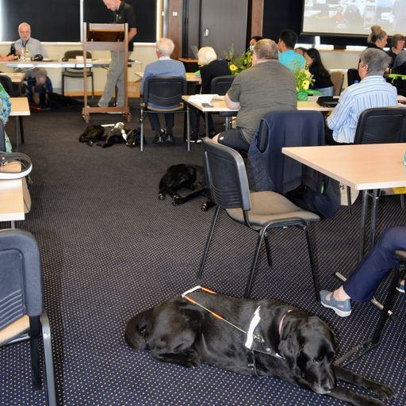
Seminar lab report – guide dogs at rest
Thank you to Dr Chandra Harrison, Director Accessibility Advisors, for capturing these moments.

Strategies that underpin our work
We acknowledge, honour, and build on the work of those who have led the way, seek the current voice of deafblind New Zealanders, and hold fast to the overarching strategies that underpin our work:
- Te Tiriti o Waitangi – The Treaty of Waitangi;
- Te Whakapuakitanga o te Rūnanga Whakakotahi i Ngā Iwi o te Ao mō Ngā Tika o Te Hunga Hauā – United Nations Convention on the Right of Persons with Disabilities (CRPD)
- Ngā Whāinga Whanaketanga Toitū – Sustainable Development Goals
- New Zealand Disability Strategy 2016-2026
- Te Mahere Mahi Hauātanga New Zealand Disability Action Plan 2019-2022
- He Korowai Oranga – Māori Health Strategy
Ends

