ADBN Logo


ADBNews: May 2024

Welcome to the May 2024 Edition of **ADBNews.** Since the last edition, I have welcomed two new cohorts of students on the Certificate and Diploma in Professional Studies (Deafblind Studies) courses I lead here in Birmingham, and I was reminded of the words of Helen Keller that “**A well-educated mind will always have more questions than answers**”. There is still a lot to learn about acquired deafblindness and as we **connect, celebrate, and grow**, one of the key aims of ADBN is to enhance understanding of the condition by developing and sharing theoretical and research knowledge, and knowledge emerging from lived experience and practice in the field. The network newsletter is one of the ways in which we realise this aim; I hope you find this edition interesting and informative. As always, huge thanks to editors Jo and Tracey, and to Carolina and Ismael for translation support.

I do hope to see members at our next webinar, but in the meantime, take care and enjoy the reading the newsletter.

All Best,

Peter

**Chair: Acquired Deafblindness Network**

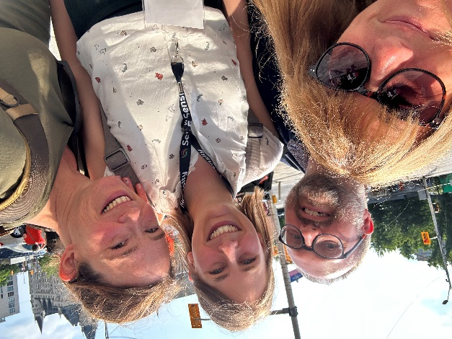

Liz Duncan, Peter Simcock, Carolin Gravel, and Femke Krijger

**ADBN Webinar Series 3:**

**Beyond Existence: Exploring & Living Life**

A well-deserved and big **‘Thank You’** to Carolina Cohoon, Jeremy Marks, and Mike Ingram for delivering the second webinar in this series, titled: **Brave New world: Accessibility to and the use of Artificial Intelligence by Acquired Deafblind People** which was held on 27th March 2024.

If you would like to revisit the webinar or missed it you can click on the link here to access a recording and transcript: [**DBI video and transcript**](https://url.uk.m.mimecastprotect.com/s/vlf-Cq7R7uzWVPmCZnihx?domain=drive.google.com)**.** The recording is also available on our YouTube Channel **ADBNow.** If you are a member and haven’t already subscribed to the channel, please do so using the link [here](https://protect-eu.mimecast.com/s/1zlFCgZYZFmNAXJIonJzM?domain=youtube.com).

Carolina, Jeremy, and Mike have also kindly provided **links to resources referred to during the Webinar**:

1. [The Axe Advisor Chatbot developed by Deque Systems](https://url.uk.m.mimecastprotect.com/s/gpLECr8Z8u19W0LFzyZF7?domain=deque.com/) is a valuable tool for understanding and implementing WCAG guidelines. It’s designed to interpret and communicate changes in these guidelines, which can often be complex and nuanced. By relying on information written by Deque accessibility experts, the chatbot can provide clear and explicit answers to questions about digital accessibility. This makes it a great resource for anyone looking to ensure their digital content is accessible to all users. Video format explaining how it works can be found at [axe DevTools: Your AI Partner for Digital Accessibility Testing - YouTube](https://url.uk.m.mimecastprotect.com/s/NVQ5CvlqlI2XRjMfzYmGc?domain=youtube.com)
2. LUDIA is an AI-powered (chatbot) tool designed to assist educators in implementing the Universal Design For Learning framework:   [Meet LUDIA, Your AI-Powered UDL Partner | The International Educator (TIE Online)](https://url.uk.m.mimecastprotect.com/s/JLG9CwV9VFAp2zYsKc_GA?domain=tieonline.com)
3. Sign language interpretation:

* [SLAIT AI](https://url.uk.m.mimecastprotect.com/s/VaQECxnqnu9Oz4rcRKMpD?domain=slait.ai/) is an Artificial Intelligence technology (Beta access) that provides real-time sign language translation. Here’s how it works: Sign Language Translation: The application recognizes gestures and displays them as text in real time; Speech Recognition: The application recognizes speech and displays it as text in real time; Video Communication: The application provides a live video connection 24/7.

1. Device Mike mentioned during his presentation: [The Rabbit R1 is an AI-powered gadget that can use your apps for you - The Verge](https://url.uk.m.mimecastprotect.com/s/Zb_dCyolot0npz9uAwQ-1?domain=theverge.com)
2. Mike Ingram’s website exploring AI for acquired deafblind people can be found [here](https://usherswithoutbarriers.com/ai-for-the-db-community/).

We are now looking forward to our next webinar in the series:

**Webinar Three: The Use of Social-Haptic Communication to enable deafblind people’s involvement in hobbies: the example of astronomy and astro-haptices.**

**Speakers: Riitta Lahtinen, PhD and Russ Palmer, Music Therapist, Tampere University, Finland.**

**Date and Time: Wednesday 5th June 2024 4.30pm (CET)**

Photo of Russ Palmer and Riitta Lahtinen, sat outdoors at a restaurant table. 

The Zoom link for joining the Webinar can be found [here](https://us06web.zoom.us/j/83347516074). A password is **not** needed to join.

# **Forthcoming Conferences and Publications**

The first ever **Regional Conference of Deafblind International in Asia** is taking place in **Pokhara, Nepal on 1st – 3rd March 2025.** Further details to follow but **save the date!**

A picture of the conference poster, which is an image of mountain in the background, with the logo of Deafblind International.  The poster includes the date and location of the conference, and the words: Explore the Beauty of Nepal, Embrace Diversity, and Connect with the Deafblind Community. 



Following the February addition of **ADBNews 2024**, just a little reminder for us to all save the date for the forthcoming **Deafblind UK Conference Standing Out and Fitting In.**

Deafblind UK 2024 conference poster.  
The logo of Standing out and fitting in is in front of a picture of 13 green apples with one red apple amongst them.

**When:** October 3rd, 2024

**Where:** Online



Following his successful and informative ADBN Webinar in January 2024 - **Families with Usher Syndrome in the Democratic Republic of Congo (DRC) -** Dr Ismael Byaruhanga has alerted us to a case study report of a man with Usher Syndrome in the East DRC. **ADBNews** are pleased to share the link to this report [here](https://acrobat.adobe.com/id/urn:aaid:sc:EU:4c128d27-e6c7-4373-8c1e-b64f4a490deb).

As a result of advances in genetic testing, Usher syndrome is now being diagnosed at a much earlier age. Whilst these advances enable the provision of early intervention and support, it is reported that there are substantial gaps in support provided to parents of children diagnosed with Usher. Colleagues in Australia undertook a qualitative study exploring the **support needs of parents of young children with Usher Syndrome**. The link to the article reporting on this study and its findings can be found   
[here](https://ojrd.biomedcentral.com/articles/10.1186/s13023-024-03125-w).

Dr Annmaree Watharow’s article on the **hospital experiences of people living with deafblindness or dual sensory impairment** has been published in the journal ‘Healthcare’. A link to the full text of the article can be found [here](https://www.mdpi.com/2227-9032/12/8/852).

**Read on in this newsletter for Part One of Annmaree’s ‘Being Prepared for Hospital’,** which offers excellent suggestions to help acquired deafblind people prepare for time in hospital.

**Celebrations and Congratulations**

**ADBN offers many congratulations** to The Heliotrope (Panhellenic Deafblind Association), particularly its President and ADBN member Katerina Bezerianou, on the design and production of its excellent **video on deafblindness and Usher Syndrome**. The video includes in screen sign language interpretation and English subtitles. You can watch the video by clicking on the link [here](https://www.youtube.com/watch?v=1TkdS-HWjRY).



ADBN also offers **huge congratulations to** member and **ADBNews** editor Jo Brady, on completing her MSc in Gerontology and passing with **Distinction. Very Well Done Jo!**

**Being Prepared for Hospital:** **Part One**

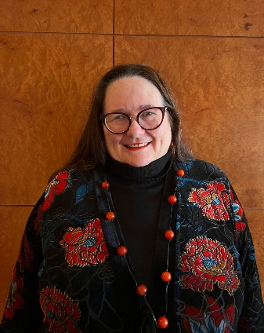**by Dr Annmaree Watharow**

Dr Annmaree Watharow is a research fellow at the University of Sydney and Author.

**The difficulties someone who live with deafblindness has when going into hospital can be profound, particularly around mobility and communication. Dr Annmaree Watharow has kindly offered some fantastic suggestions to prepare for hospital. This is not only helpful for admissions but also day hospital visits.**

Preparing for hospital is crucial if you live with deafblindness or dual sensory impairment. It can help improve communication with doctors and nurses so we can let them know exactly what we need and understand what is going on. Here are some steps to prepare:

1. Choose a suitable bag as your going-to-hospital kit, preferably cloth and brightly coloured or with tactile stickers. Keep your going-to-hospital kit in a consistent spot at home, for example, the back of the bedroom door or a designated drawer, so that it is easy to find.
2. Organise all necessary information and documents in one place, both in hard copy and electronically on your phone, so that it is readily accessible.
3. For electronic copies, create an online folder or use an app to store emergency health information. Take screenshots of medication labels and important documents like vaccination certificates and put them in this folder.
4. Document all your health details including allergies, past operations, past medical issues, family history, current medications, vaccination records and your current health conditions or illnesses.
5. Document all your disability information and care plans, including what your hearing is like, what your vision is like, and what the diagnosis is for each sensory loss. It is also helpful to write out just how these impairments affect you, for example, “I can’t hear in crowded spaces”. The more information, the better.
6. Provide your communication preferences. This will give staff different ways to communicate if one way does not work. We suggest listing five methods. We will all have different top five communication methods but for me, as an example:

* putting on hearing aids
* using pen and paper to write in big letters
* using a whiteboard
* using speech-to-text on my device
* calling my partner for information

1. If you use touch messaging, include touch messaging instruction documents such as the manual alphabet or social-haptics touch messaging. Take multiple copies for hospital staff and ask them to display them above your bed. This will reduce the work of constantly explaining what we need.
2. Include a list of the contact details of your ‘super team’ members and what they look after. Your super team is all the people who support you and this will ensure you and the hospital can reach them if necessary.
3. Include instructions for any devices you use, such as how to change batteries in hearing aids or to recharge your cochlear implant.
4. Add in wristbands or lanyards if you use them. It may be better to wear your wristband as the lanyard can be a problem if you are going into theatre or need ECG dots on your chest.
5. Add in spare supplies like thick black pens, wipes for whiteboards, and extra batteries for hearing aids and cords for devices.

We look forward to Part Two of Dr Annmaree Watharow’s blog - **Being prepared for emergencies -** which will be included in the next edition of **ADBNews**.

**A Few Thoughts on this ‘Asking for Help’ Business   
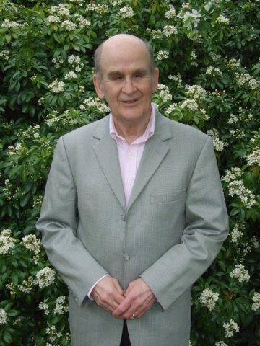by Roger Wilson-Hinds**

**Continuing our series of articles exploring ‘seeking and providing help’, Deafblind UK Trustee, Roger Wilson-Hinds, reflects on his recent experiences of moving house.**

We have had a most hectic and learning time here in new surroundings and without our familiar friends and support network. If we survive, and we will, then the way to overcome old age is to push yourself and stretch your abilities and senses. It used to be so easy moving home, going to new places, smiling, and seeking help. This time round we have struggled with the noisy and busy traffic, and we have not been able to quickly orientate to our new home and environment. But the dogs have been great, and we have enjoyed some extended family time and hours out with our grandchildren.

Not sure how being deafblind has impacted on our situation but I have not been my usual well self. I wanted to share a few further thoughts on this asking for help business, as it has affected us of late.

**So, three headings:**

**Getting help from professionals.**

**Getting help from technology.**

**Being aware of needing more help than previously.**

I have never asked or needed to ask for practical help from social services or Deafblind UK but over the last few weeks I could have used some mobility support and a good eye and strong body in our lives. Away from our long-standing  support network, we were in some [trouble. So](https://url.uk.m.mimecastprotect.com/s/1q3-C2x4xTROkgkCnlL-s?domain=trouble.so) I am thinking that many of us deafblind people ‘jog along’ OK until the crisis comes, and the professional specialist support does not or cannot be ready to meet crises.

Since we got here, we have had no reliable internet, just the iPhone. All this when we can’t use pen and paper to cope with the many removal arrangements or dip into the new washing machine manual or the oven controls. But there is an app which has really come into its own in our lives:

So, you tap the phone button and say, “Be My Eyes”. There are over two million volunteers and one of them answers your call and is willing to read for you, look for something for you or even describe where you are, street number or name of shop, if no humans are nearby. It works via speech output which I can still hear but not always in noisy traffic, but it also works with a braille display, so hopefully it will work for me in the future. It’s a great way to get human help without constantly leaning on a family member or support carer.

**More information can be found on the following link**

**Be My Eyes. **[**www.bemyeyes.com**](http://www.bemyeyes.com)

So, all in all, I have learned so much about asking for help and getting help from others. Out walking with each other and our dogs, my wife Margaret and I have several times lost contact with each other in the noisy traffic. Several times we have not been aware of another nearby person to call out to. Whether we need some kind of permanent care or not, I am not sure; but I do know that we, and others in crisis or challenging situations, do need to be able to call in emergency assistance, if only until we have sorted things in our new situation and new comfort zone. Death of partner or significant other, new home, significant illness, and so on would all count as triggers for emergency help as would various mental stresses or depression.

One may get used to various levels of deafblindness without too much intervention, so long as the hearing aids work, the basic support is there in some way and the money comes in. But when there is a fire the fire engine is needed and when the leg is broken the hospital is needed; I have learned that the deafblind fire engine does not exist.

We are OK and are getting there and soon we will have a new home to be very proud of and we will know our way round our new environment like the back of our hands so long as we have each other’s love.

**World Federation of the Deafblind (WFDB) – Youth Committee**

What fantastic news for young individuals with deafblindness (aged 18-35) who can apply to join WFDB’s **newly established Youth Committee**. This committee aims to provide a dynamic platform for young volunteers with deafblindness to actively contribute to the organization's mission and initiatives, while also providing opportunities for networking, CV enhancement, and increased visibility as advocates.  For more information about the Youth Committee and application guidelines, please visit the website [here](https://wfdb.eu/2024/03/20/join-wfdbs-youth-committee-call-for-deafblind-representatives/).

**The deadline for applications is 2nd June 2024.**

**World Federation of the Deafblind (WFDB) and Deafblind International (DbI) commit to collaboration.**

The World Federation of the Deafblind (WFDB) and Deafblind International (DbI) have formally signed a Memorandum of Understanding (MoU). This **landmark agreement** solidifies their **commitment to collaboration** and **alignment of strategic actions** related to the awareness and broader understanding of the rights and needs of persons with deafblindness and the establishment, development, and promotion of disability-specific services to all persons with deafblindness. The Memorandum will serve as an outline to support each other’s strategic goals and initiatives.  The signing of the MoU between WFDB and DbI represents an **important step forward in the global movement to promote the rights and well-being of individuals with Deafblindness, and their network.**

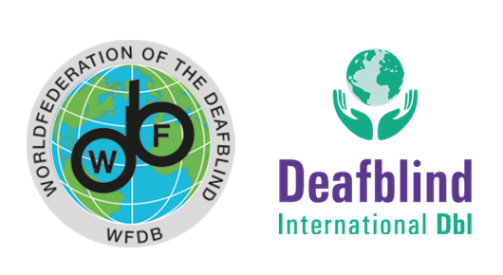

Access to the Memorandum of Understanding between Deafblind International (DbI)and the World Federation of the Deafblind (WFDB) in Word Version can be found [here](https://security-eu.mimecast.com/ttpwp/#/checking?key=wlSTxl1Fv-wdtqllGMNqkaRpTxvjLI0qmSNu8LFOdnK1rW8Ep7xYTP0T5JPMJhXre-1D2b_LLsGS4TwYixuun8K1ajyygY22EJL97_6okW9RaxOE0x9IT9PFiD1mEL4W).

**Dates for the diary**

**ADBN Webinar Number Three**: 5th June 2024

**Deafblind Awareness Week:** 24th – 30th June 2024

**Deafblind UK conference – Standing Out & Fitting In:** 3rd October 2024

# **ADBN: Supporting and Connecting with YOUR Network**

ADBN continues to grow, and we now have **over 400 members worldwide**. This is excellent news. However, this is YOUR network, and **we continue to need** support maintaining and developing its work, so **please get in touch** if you can offer support:

* Presenting at and Facilitating Webinars
* Interpreting & Translation Support at Webinars and for other ADBN communications
* Contributing to **ADBNews**

If you wish to contribute to **ADBNews**, including submitting an article, sharing news, or making a request for information, please contact **ADBNews** editors:

* Jo Brady and Tracey Osbourne: [sensory@thurrock.gov.uk](mailto:sensory@thurrock.gov.uk)

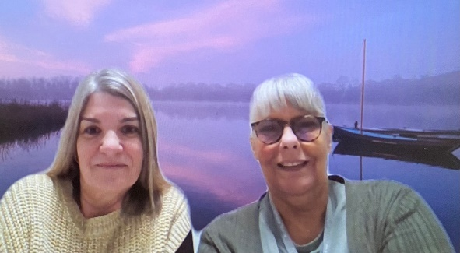

**Do you have a family member, friend or colleague who is interested in joining ADBN?**

If so, please do ask them to complete the DbI membership form – available [here](https://www.deafblindinternational.org/become-a-member/individual-members/register/) – and to select ‘**Acquired Deafblindness Network’** when asked about networks in which they are interested. We will then be in touch.

Deafblind International ADBN Logo. 
