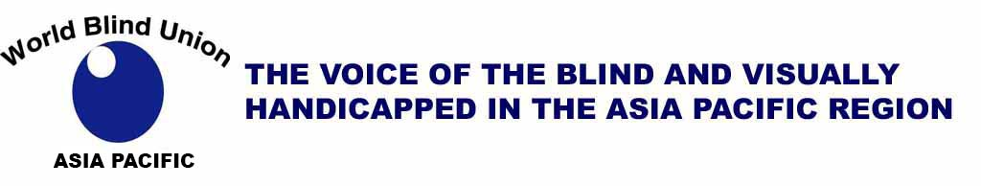

The 17th WBUAP Regional Massage Seminar 2025

The Organizing Committee of the 17th WBUAP Regional Massage Seminar 2025 invites you to submit paper abstracts for presentations at the plenary sessions, which will take place from August 27 to 29, 2025. If you wish to make presentation, please follow the submission guidelines below:

\* Deadline for submission of paper abstract: September 30, 2024

\* Notification of selection results: October 31, 2024

\* Deadline for submission of full paper: May 31, 2025

Maine Theme: Sharing the Strategies for the Sustainable Development of Blind Massage in the Asia-Pacific Regions

Sub-themes

① Education and In-service Training in Blind Masseurs

② Best Practices in the Management of Blind Massage Centres

③ Legal and Policy Issues Regarding Blind Massage in the Asia-Pacific Regions

④ Research in Demonstrating the Effectiveness of Blind Massage

\* When submitting your abstract, please be sure to include your name, country, and the related sub-theme.

The Programme Committee, will carefully evaluate all submitted paper abstracts.

If Programme Committee considers your paper is appropriate for presentation at the Seminar, you will be notified and requested to submit the full paper by May 31, 2025.

Please direct all communicationsto the Organizing Committee at:

kbupoli1015@naver.com

Sincerely,

Korea Blind Union

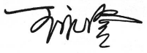

Wang Yongcheng KIM YOUNGIL

Chairman Chairman

WBUAP Regional Massage Commission Organizing Committee

17th WBUAP Regional Massage Seminar