Society for Empowerment of the Deaf-blind, India
No.4 Shop Kazi Kabrastan Pakhal Road, Dwarka Nashik - 422002, Maharashtra, Email: Info@sedbIndlo.org | Website: www.sedbindla.org Reg No.
Maha/589/Nashik Date: 20-10-2015, M.P.T. No. F-/16186 Date: 31-12-2015
Date:
To:
Subject: Invitation to the 3rd National Conference of the Deaf-Blind (NCDB) 2025
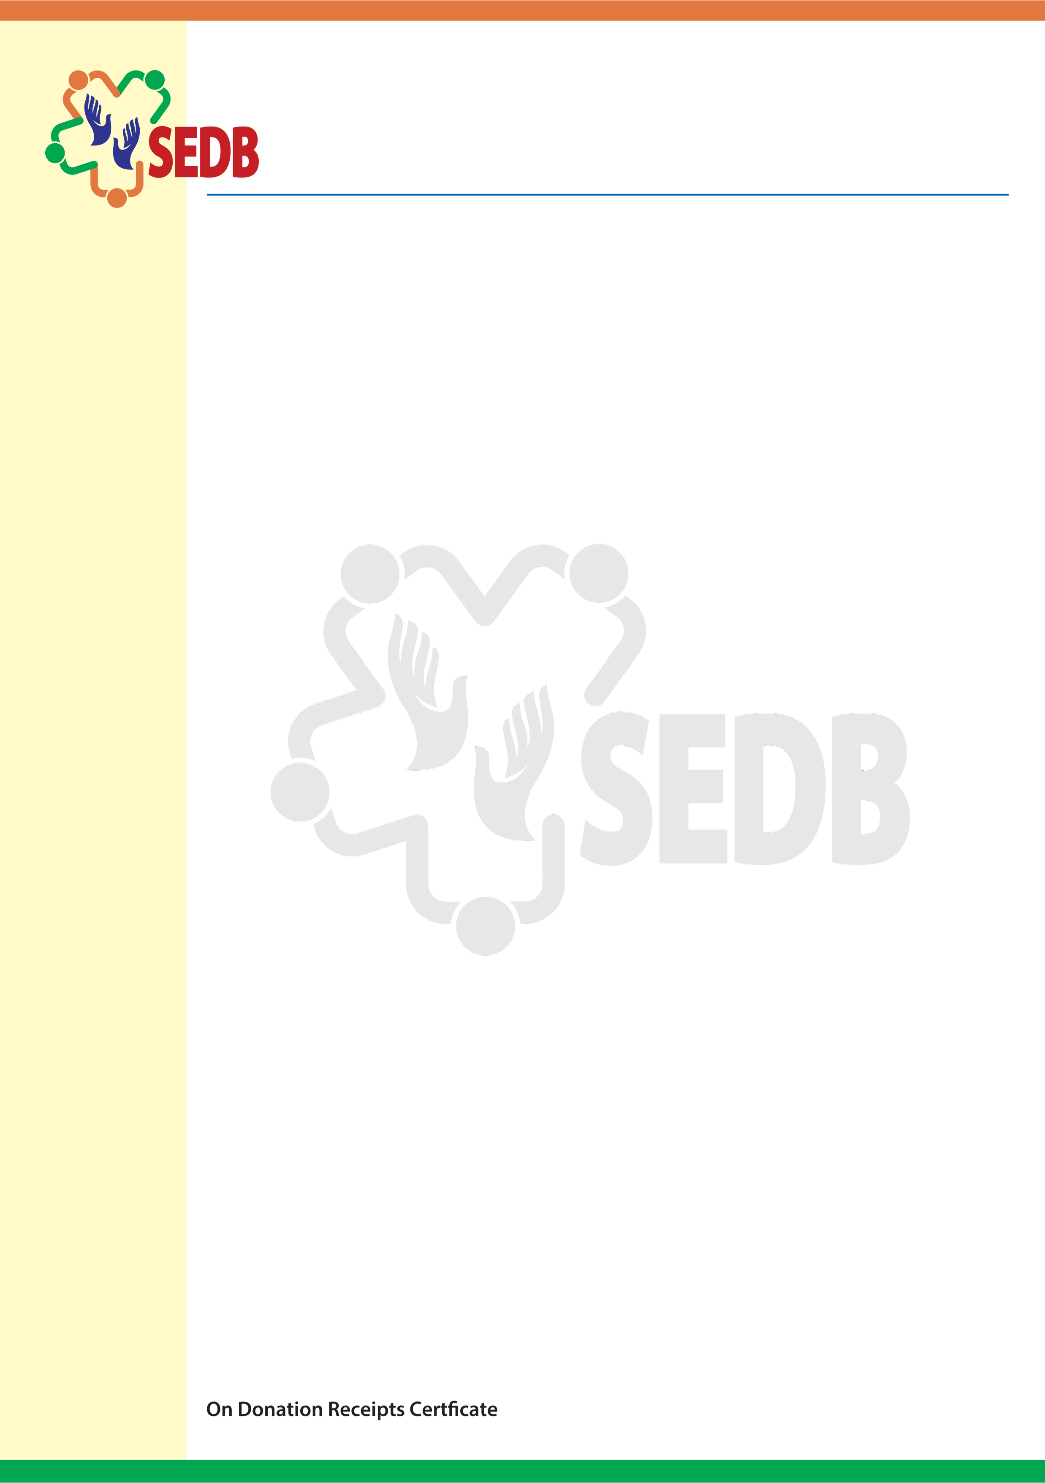
Dear Deaf-Blind Member and access provider, family member or interpreter, I hope this letter finds you in good health and high spirits. I am delighted to announce that the 3rd National Conference of the Deaf-Blind (NCDB) 2025 will be held in Chennai on 31st January and 1st Feb 2025. This event is funded by the Department of
Empowerment of Persons with Disabilities (DEPWD) under the Ministry of Social Justice and Empowerment (MSJE), Government of India, and is supported by NIEPMD Chennai, Vidya Sagar, Chennai, and Chetana Trust, Chennai.
Travel and Accommodation

Please plan to arrive at Chennai Central station on 30th January and depart on 2nd February.
Please book your train tickets in 3AC or Sleeper Class using your railway concession certificate or UDID card, if applicable. Kindly carry your original train tickets to claim reimbursement.
Accommodation has been arranged for you at Dhyana Ashram, mada church road, Chennai on twin sharing basis.
Inform us of your ticket details, including train number, arrival time in Chennai, and whether assistance is needed. A bus/van will be available for pickup from the railway station. If your arrival or departure is not on the given dates, you will need to make your own travel and stay arrangements

Additional Information
Remember to carry your medications and any emergency support items you may need.
Escorts are essential; you must be accompanied by your parent or access provider. If you are traveling alone, please inform us in advance so we can arrange an interpreter for you at the venue.
Tactile signing interpreters will be available to assist you.
Meals: Breakfast, lunch and dinner will be provided for the period of your stay.
Please adhere to the rules and policies of the venue. If you have any questions or need further
assistance, feel free to contact Pradip Sinha or Sunil Abbas.

We sincerely thank you for your support and cooperation and look forward to meeting you at the event.
Warm regards,
Pradip Sinha
Honorary Chairman
Society for the Empowerment of the Deaf-Blind (SEDB) India

