ADBN Logo


ADBNews: December 2024

Welcome to the December 2024 Edition of **ADBNews**. Since the last edition, our network has continued to grow, and we now have over **490 members**, some of whom I had the pleasure of meeting in person at the WHO ICF Core Set for Deafblindness Conference in Spain in October. More about this conference in the next edition. In June this year, members were involved in a range of activities to mark Deafblind Awareness Week and the International Day of Deafblind People. This included those hosted by member Moussa Nasser, President of ISF-Multi-Handicap in Niger. In this edition of **ADBNews**, we are delighted to announce the details of our **fourth series of webinars**, with another great line up of speakers. This edition also includes Part Two of Dr Annmaree Watharow’s article, which explores preparedness for emergencies, as well as providing information on the latest publications, upcoming conferences and the premiere of an award winning documentary. As always, I offer my huge thanks to **ADBNews** editors Jo and Tracey, and to Carolina and Ismael for translation support.

I do hope to see members at the first webinar of our new series in January, but in the meantime, take care, very best wishes over the festive season, and enjoy the reading the newsletter.

**All Best,**

**Peter**

**Chair: Acquired Deafblindness Network**

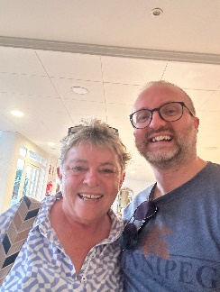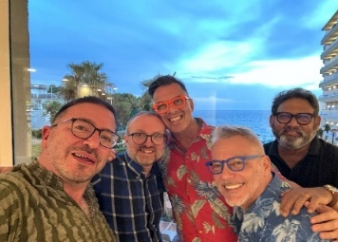

# **ADBN Webinar Series Four: Balancing Loss and Potential**

We are delighted to announce the programme for the fourth ADBN webinar series, which adopts the theme ‘**Balancing Loss and Potential’**. Starting in **January 2025**, we have a great line up of speakers. The Zoom links for each webinar will be made available to members shortly before the event, but please note the dates/times in your diaries now.

**Webinar One:**

***The Balancing Artist: How I am Learning to Perceive as I become Deaf and Blind.***

Speaker:

**Femke Krijger LL.M**

**Researcher, Author, Holistic Therapist: The Netherlands**

Date/Time:

**Wednesday 29th January 2025 4.30pm (CET)**

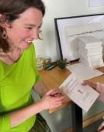

**Webinar Two:**

***Walking in Two Worlds***

Speaker:

**Hannah McPierzie**

**Educator, Advocate, Speaker: Western Australia.**

Date/Time:

**Wednesday 26th March 2025 4.30pm (CET)**

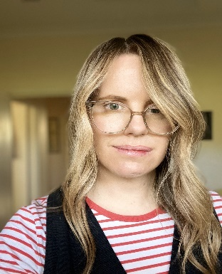

**Webinar Three:**

***Connecting Youth and Adults with Acquired Deafblindness: An Action Research Study to Gain Insights into the Benefits of Age Diversity in Peer-Matching***

Speaker:

**Vikram Choudhary**

**Special Needs Educator, Deutsches Taublindenwerk: Germany**

Date/Time:

**Wednesday 21st May 2025 4.30pm (CET)**

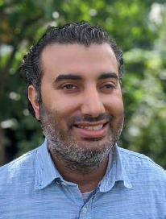

**Webinar Four:**

***Identity Threads: Professional is Personal is Creative***

Speaker:

**Amanda Stevens**

**Executive Officer Taringa Turi Kāpō Rōpū**

**Deafblind Association of New Zealand Charitable Trust: NZ**

Date/ Time: **3rd September 2025 4.30pm (CET)**

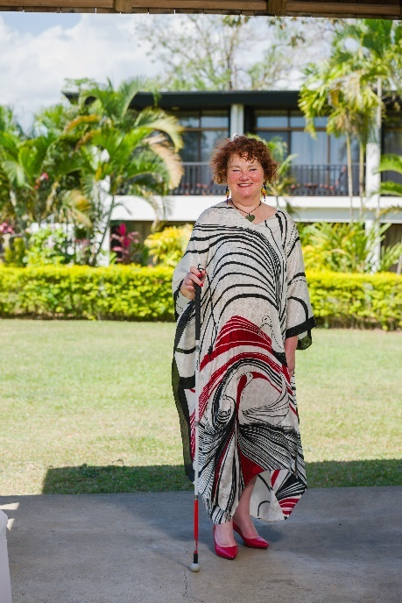

# **ADBN Webinar Series Three Recordings**

The recording of **‘The Use of Social-Haptic Communication to enable deafblind people’s involvement in hobbies: the example of astronomy and astro-haptices’’** delivered by Riitta Lahtinen PhD and Russ Palmer PhD h.c., is now available and can be found [here](https://url.uk.m.mimecastprotect.com/s/Be3xCYWpWtggD9rUzfwuxYIie?domain=youtube.com). Huge thanks to Riitta and Russ, for a very informative and interesting presentation.

Photo of Russ Palmer and Riitta Lahtinen, sat outdoors at a restaurant table. 

The recording of the final webinar in the third series, ‘**Parenting and Acquired Deafblindness: The Experiences of Children and Parents’** delivered by **Dr Ann-Sofie Sundqvist (Örebro University, Sweden) and Angela Priestly (Deafblind UK, UK)** is also now available and can be found [here](https://www.youtube.com/watch?v=fEVz_-cSHzs).Another superb presentation, many thanks to Ann-Sofie and Angela.

Head and shoulder photos of Ann-Sofie and Angela Priestly.

Do remember that recordings of all ADBN webinars can be found on our YouTube channel, **ADBNow,** a link to which can be found [here](https://url.uk.m.mimecastprotect.com/s/eGtGCXLxLhGG49wCXcguW8RWt?domain=youtube.com).

# **Publications and A Documentary Premiere**

Congratulations to members Dr Annmaree Watharow and Dr Moira Dunsmore on the publication of their latest book called **‘Dual Sensory Impairment and the Older Person: An Invisible Epidemic?’**. The book explores the experiences of older adults living with multiple or dual sensory loss, and the social consequences, barriers, and stigma faced by older deafblind people and their loved ones. It promises to be a very thought-provoking and interesting read. Further details about the book can be found [here](https://livedplacespublishing.com/book/isbn/9781915734358).

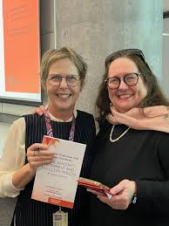

**Congratulations Moira and Annmaree!**

Members Dr Walter Wittich, Carolin Gravel, Dr Atul Jaiswal, Renu Minhas and other colleagues from the **WHO ICF Core Set for Deafblindness** Team have published findings from qualitative interviews and focus groups with deafblind people, exploring perceived barriers and facilitators to functioning of body functions and structures, activities and participation, and environmental and personal factors. A link to the full text of the paper, titled “**Development of core sets for deafblindness using the International Classification of Functioning, Disability, and Health: the perspectives of individuals with lived experience”** can be found [here](https://deafblindontario.com/wp-content/uploads/2024/11/Wittich-et-al-Eur-J-Phys-Rehabil-Med-Lived-experience-study.pdf).

Members may be interested in reading the **World Federation of Deafblindness (WFDB) manifesto for 2024**. Its latest initiative is to advocate for the UN General Assembly to officially recognise 27 June as **International Day of Deafblindness**. The full text of the manifesto can be found [here](https://wfdb.eu/2024/06/27/manifesto-on-international-day-of-deafblindness-2024/). [Odyssey Global Media](https://url.uk.m.mimecastprotect.com/s/TqVwCQnJnu99XR0COIJuGBsE3?domain=odysseyglobalmedia.com) interviewed **WFDB President Sanja Tarczay and WFDB Program Advisor Lucia D’Arino** about their work and the organization’s activities. This included the campaign for the [International Day of Deafblindness](https://url.uk.m.mimecastprotect.com/s/i6DrCROYOuQQGO2fESzu1nVnc?domain=wfdb.eu/). Details for accessing the podcast recording and transcript of this interview can be found [here](https://wfdb.eu/2024/07/25/wfdb-representatives-are-interviewed-about-their-work/).

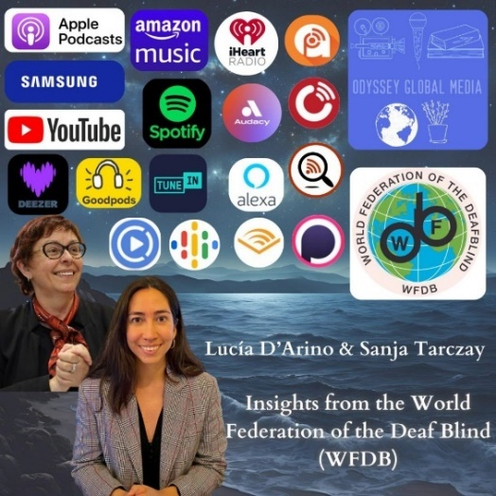

ADBN extends **thanks to member Alex Garcia** who shared his thoughts about the **International Day of Deafblind people.**

### Photo of Alex Garcia looking relaxed and smiling

### “As usual, doing it my way! Hello. On Thursday June 27th, the International Day of Deafblind people. This year let's reflect on what Oscar Wild taught us: "Selfishness is not living our own way but wanting others to live the way we want them to.” Health and Peace!

You can explore more from Alex on YouTube using this link: <https://www.youtube.com/watch?v=4mq5QF5BBSc>

And on Facebook, here: <https://www.facebook.com/share/p/nMp94xKs66E7LpoM/>

Alex’s poem, “**Dreams of a Deafblind Person**” has also now been translated into **Polish**; the link to this translation can be found [here](https://www.agapasm.com.br/Artigos/In%20polish%20-%20Dreams%20of%20a%20deafblind%20person.pdf). The poem has now been translated into **more than 21 languages**! Congratulations Alex!

**Imagined Touch**

Award winning documentary **Imagined Touch**, featuring Acquired Deafblind performers Heather Lawson and Michelle Stevens, and directed and produced by Jodee Mundy, premieres this month on Australia’s SBS TV network.

Further details can be found [here](https://www.sbs.com.au/ondemand/tv-program/imagined-touch/2387404355967) and the trailer for the documentary can be found [here](https://www.youtube.com/watch?v=xPnXbk1_j5U).

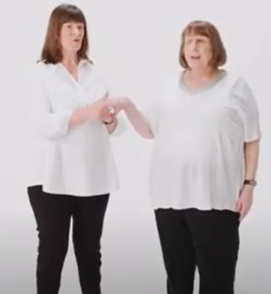

# **Forthcoming Conferences**

The first ever **Regional Conference of Deafblind International in Asia** is taking place in **Pokhara, Nepal on 1st – 3rd March 2025.** Further details can be found [here](https://www.deafblindinternational.org/nepal-2025-registration-and-call-for-paper/).

A picture of the conference poster, which is an image of mountain in the background, with the logo of Deafblind International.  The poster includes the date and location of the conference, and the words: Explore the Beauty of Nepal, Embrace Diversity, and Connect with the Deafblind Community. 



Registration for the **USH2025 Scientific Congress**, taking place on **19th-20th June 2025** is now open. This congress focuses on knowledge sharing and aims to connect and encourage collaboration and crossovers between different fields of medical expertise. Further details can be found [here](http://www.USH2025.org/en/) and information on registration and the call for abstracts can be found [here](https://www.ush2025.org/en/informatie/inschrijven-en-kosten/).