# Part 2

# **Celebrations and Congratulations**

Birmingham City University in the UK held its third annual Knowledge Exchange Awards on 26th June 2024. This annual event celebrates the outstanding contribution of Academic and Professional Services staff in supporting the exchange of knowledge into the wider community, ranging from businesses to community groups. It serves to exemplify the University’s contribution to society, and the economy at local, national and international levels. We were delighted to learn that the **Acquired Deafblindness Network (ADBN) Webinar Series** was **highly commended** at this awards ceremony, in the category “**Best Knowledge exchange project with public/third sector category**”. We would like to extend our thanks and celebrate both the organisers of our webinars and the fantastic speakers we’ve had for connecting ideas and growing our knowledge over the last three series. **Huge congratulations and we all look forward to series four!**

ADBN offers **huge congratulations** to member and highly talented digital artist, **Ava Jolliffe** on being nominated and shortlisted for a UK National Diversity Award.  Details about her amazing nomination can be found [here](https://www.nationaldiversityawards.co.uk/awards-2024/nominations/ava-jolliffe/?fbclid=IwAR2bFQqezlTtCOsou3llykHZ6RkDYjHQkP5vxMC47F514Rw20PB6EwxUK1c).

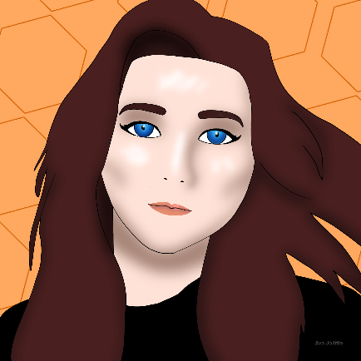

ADBN offer further congratulations to member **Russ Palmer** on receiving his honorary doctorate from the University of Oulu, Finland. This is in recognition of his pioneering work with music therapy and research. His academic journey and professional achievements have been marked by an unwavering dedication to research, innovation, and education. His work has significantly advanced communication for those without visual and auditory senses and has made a lasting impact on both the academic community and society at large. **Many Congratulations Russ!**

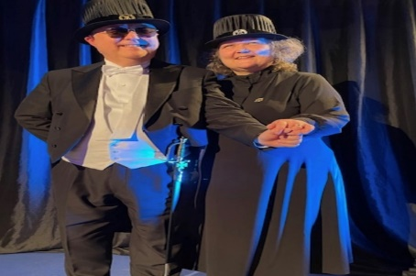

Following the ceremony, Russ was joined by friends and colleagues at his **Karonkka**. A Karonkka is a traditional Finnish post-doctoral party, and those attending enjoyed delicious Lappish cuisine, moving speeches about the impact of Russ’ work and a wonderful musical performance by Russ and Juha Sarkkola.

# **Being prepared for emergencies: Part Two**

# **Dr. Annmaree Watharow**

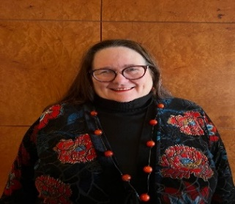

**In May’s edition of ADBNews, Dr Annmaree Watharow, a research fellow at the University of Sydney, shared her useful article ‘Being Prepared for Hospital’. Here in Part Two, she reflects on ‘Being Prepared for Emergencies’.**

Living with deafblindness or dual sensory impairment is a complicated thing. Risks are increased; for example, falls and misreading or mishearing instructions for our medicines. We often have other disability and conditions. All of these mean we may go to hospital more often than some other people do. We experience climate emergencies like floods, fires, heatwaves, just like everyone else.

So good emergency planning is important. This means we need to:

1. **Have the conversation**

We need to talk to our family, friends, neighbours and support networks now, before an emergency happens. Being connected socially is important. How will we know a disaster such as a flood is unfolding? Can a neighbour or a family member come and alert us and help get us to a safe place? How will we alert someone if we have a fall at home and can’t get up? Do we need a personal alarm? These conversations about what we might need to help keep ourselves safe and get help are really important. Start making an emergency plan, now.

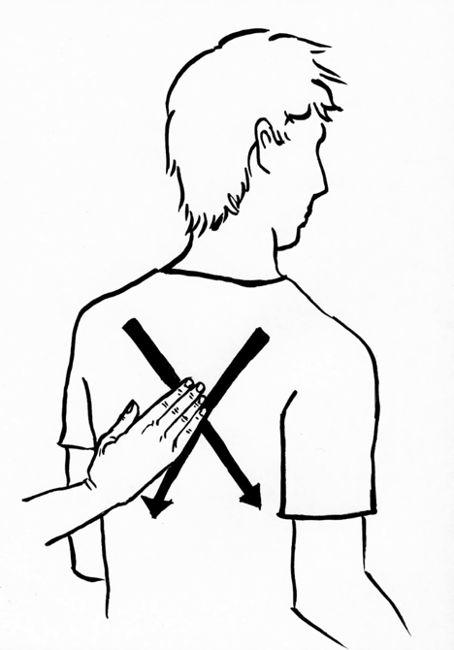During these conversations, we need to think about how other people are going to let us know there is an emergency unfolding such as a gas leak in a building. One way for deafblind people or those with dual sensory impairment who don’t see too good or hear too well, is to have a touch message. Social-haptics communication has a universal emergency touch sign where a large X is drawn on the back using either the blade of the hand or two fingers pressing firmly. This means there is an emergency, come with me now, put arm in mine and I will explain later. Tell everyone this is being used so that they know what to do to alert quickly. Write it down (this picture can be used) to show an emergency service worker the touch signal.

**2. Be as well as possible**

Now we need to get everyday life and chronic conditions under control. We may need to talk to their GP to access referrals and resources, and also to get extra scripts so we can have a supply in our emergency kit. We need our homes and gardens to be well maintained so we are safer at all times not just in a natural disaster.

1. **Create an emergency kit**

This means having supplies for surviving a week with no food, water, power, medication deliveries. We need to gather : essential medications, first aid kit, bottled water for a week (look for a brand that older hands with reduced dexterity can easily open unaided), large container of disinfectant, emergency food supplies, batteries and a flashlight/torch/portable radio (talk to a GP or social support provider if unable to hear a radio, amplified ear buds or a personal amplifier may be of use here but spare batteries are needed for everything). Another option if we rely on our mobile phone for communication is a powerbank that can last several days if the power is cut.

Each person's emergency kit will be different as each person's capabilities and resources are different. Don’t forget pet food supplies and to check every year that the contents of the kit are still “in date” and safe to consume.

1. **Establish and maintain social connections**

Our networks are so important in an emergency: This means communicating with family, friends, neighbours, support workers, and community organisations. This also means knowing who neighbours are even if it is just for a brief conversation. Knowing what support people can and can’t offer in an emergency is important.

1. **Communicate the plan**

Finally, the plan should be communicated to everyone in our support network, so everyone knows. If there are gaps or missing supports, everyone should collaborate to find a solution or alternatives. Tell everyone the touch message for emergency if this is used.

For more information on Person-Centred Emergency Preparedness, click [here](https://collaborating4inclusion.org/pcep/).

# **Request for Information**

Member and President of the PanHellenic Association of Deafblind People Katerina Bezerianou is seeking information on **European companies** that provide **red and white canes** for deafblind people. In Greece, only white canes are available. The position is similar in the UK, with many services marking white canes with red tape, though the Royal National Institute of Blind People has recently started stocking red and white canes: one of these is a red and white symbol cane (used only to indicate to others that the person is deafblind), details [**here**](https://url.uk.m.mimecastprotect.com/s/LH84C1BwVsxLVByFLfEHV6FNq?domain=shop.rnib.org.uk)**;** the other is a red and white long cane for deafblind children, details [**here**](https://url.uk.m.mimecastprotect.com/s/1A3OC21kGCW0MZqc1hAH5_M_j?domain=shop.rnib.org.uk).

If you know of any companies in Europe from whom the Panhellenic Association may be able to order red and white canes, **please contact Katerina directly**: [**kbezerianou@gmail.com**](mailto:kbezerianou@gmail.com)

# **Meet the ADBNews editors: Jo Brady & Tracey Osbourne**

# **A photo of Jo Brady and Tracey Osbourne, both with hair tied back and wearing white summer tops.**

Our editors, Jo & Tracey work for Thurrock Council sensory service. Similar to most councils in the UK, they are the only sensory workers in that council. Jo’s background is in social work and Tracey’s in sensory rehabilitation.

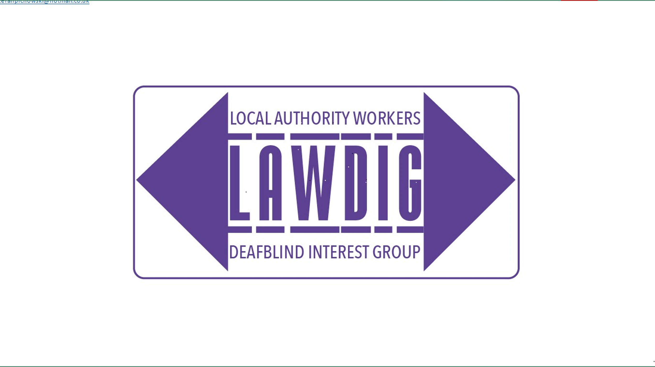 Alongside their day work, Jo and Tracey also organise and co-chair meetings for the national **Local Authority Workers Deafblind Interest Group (LAWDIG).** LAWDIG has 140 sensory practitioners from across England and Wales, who meet online four times a year.

The purpose of the group is to **share good practice** and **support each other with problem solving**. The group invite speakers to help keep up to date with the law and policy, new technology and the latest research. ​

The LAWDIG forum is an opportunity for networking and to highlight deafblind matters nationally. In 2019, LAWDIG produced an e-book ‘**Personal Accounts of Living with Deafblindness’** which was successfully launched in the UK parliament. In addition, through the Principal Social Work network, a copy was sent to every social care worker in the UK, irrespective of discipline, and was very well received. In 2024, members, in conjunction with Deafblind UK and ADBN Chair Dr Peter Simcock, presented to senior local authority managers in England, reminding them of their legal responsibilities to deafblind adults. Feedback on this webinar was extremely positive. Links to the webinar and materials can be found below.

Click [here](https://www.youtube.com/watch?v=nn93BdAe1hw) to watch a recording of the webinar

Click [here](https://deafblind.org.uk/wp-content/uploads/2024/06/Deafblindness-and-the-care-act-your-legal-obligations.pdf) to download the slides

Click [here](https://deafblind.org.uk/wp-content/uploads/2024/06/Deafblindness-hidden-in-full-view.pdf) to download Enabled Living's e-book, 'Deafblindness in hidden view', referred to in the Webinar.

LAWDIG members were also invited by the UK Cabinet Office to present information about current barriers faced by, and improvements needed for deafblind British Sign Language users in relation to their access to health and social services.

For more info or to join LAWDIG, please e-mail Jo & Tracey:

[**sensory@thurrock.gov.uk**](mailto:sensory@thurrock.gov.uk)

# **ADBN: Supporting and Connecting with YOUR Network**

ADBN continues to grow, and we now have **over 400 members worldwide**. This is excellent news. However, this is YOUR network, and **we continue to need** support maintaining and developing its work, so **please get in touch** if you can offer support:

* Presenting at and Facilitating Webinars
* Interpreting & Translation Support at Webinars and for other ADBN communications
* Contributing to **ADBNews**

If you wish to contribute to **ADBNews**, including submitting an article, sharing news, or making a request for information, please contact **ADBNews** editors:

* Jo Brady and Tracey Osbourne: [sensory@thurrock.gov.uk](mailto:sensory@thurrock.gov.uk)

**Do you have a family member, friend or colleague who is interested in joining ADBN?** If so, please do ask them to complete the DbI membership form – available [here](https://www.deafblindinternational.org/about-us/become-a-member/individual-members/register/) – and to select ‘Acquired Deafblindness Network’ when asked about networks in which they are interested.

Deafblind International ADBN Logo. 
